Adding Validation

Creating the Presentation Layer 1
Before you Begin 1

Creating the Presentation Layer

Before you Begin
Make sure that you have completed the work for last week and that you have watched the eLectures for this week before starting this work.

The final test of this functionality is to add a presentation layer to our work.
(Do I need to remind you to start your Git Hub day?)
You should already have a web form called AnAddress.aspx…
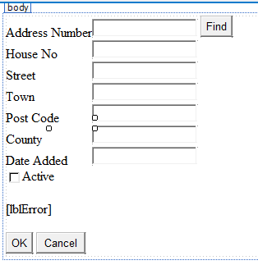
Double click the OK button to access the event handler for the control.
You should already have some existing code along the lines of this…
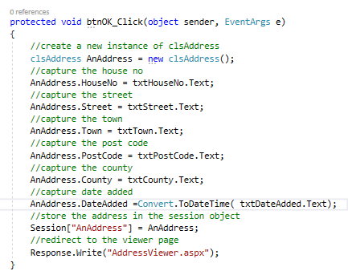
Modify this code like so such that it makes use of your validation method…
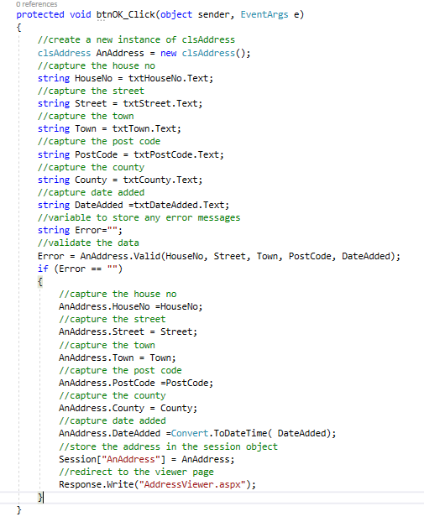
Notice how we now capture the inputted data to the string variables first and then pass these values to the validation method.
Lastly try the following code to add on some feedback to the user…
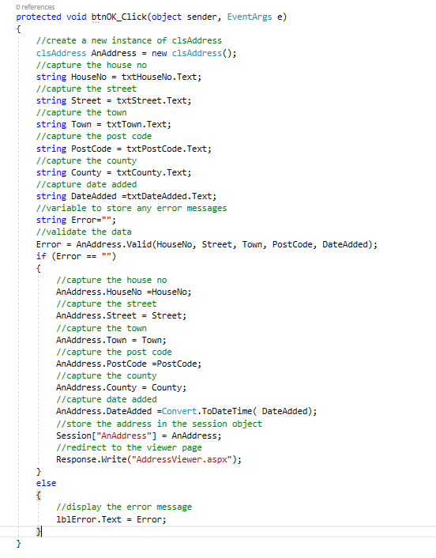
Test out the feature with valid and invalid data to see if errors are trapped with the correct error messages.
Lastly end your Git Hub day!

